­­­­Cairo University  
Faculty of Computers and Information



**CS251**

**Software Engineering I**

Project Name

Software Design

Team Names

December& 2016-12-12

# Team

|  |  |  |  |
| --- | --- | --- | --- |
| **ID** | **Name** | **Email** |  |
| 20140377 | Omar abdulazizsaeed | omer.alqubati@gmail.com |  |
| 20170375 | Hameed Mohammed Abdullah | Hameed203083@gmail.com | Leader |
| 20140367 | Asseel Ahmed mohmed | asseel7723@gmail.com |  |
| 20140339 | Wafaasamirahmedalahmer | fofoalah@gmail.com 20140339 |  |
| 20140341 | Ziadamer al-tahhan | ziadaamer 9@gmail.com |  |

# Document Purpose and Audience

**Document:**

This document contains the Class Diagram and Sequence Diagram of the Following Use Case

(Play Game , Add Game , Register )

**The Audiences:**

The Audiences are the ones involved in the production of that software:

product managers, project managers, Software engineers, designers, developers, and testers.

# 

# System Models

## I. Class diagrams

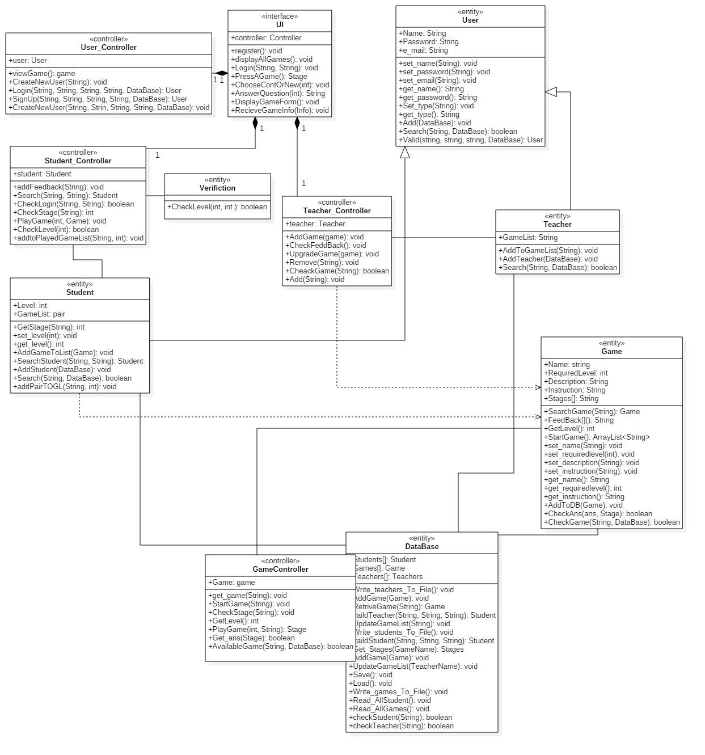

| **Class ID** | **Class Name** | **Description & Responsibility** |
| --- | --- | --- |
| 1 | UI | Interface that Connect between the User and the website System (logic and controllers...). |
| 2 | User | Contains the common information of the different users (Student and Teacher) |
| 3 | Teacher | Contains List of games created by him ,also he can add games to database |
| 4 | Student | Contains List of played games , the student level ,Retrieve Specific Student ,and get Stage of game played by student. |
| 5 | Game | Contains Information of game like :name of game , and level Required for this game ,Description of game and Instruction for play game. |
| 5 | DB | Contains array of Users ,Array of Games  ,and operation to deals with data base ex:  Insert Users ,Game ,Relative User, Game, and Update game list of user. |
| 6 | User_ Controller | General Controller connect to Web Site Interface. |
| C | Teacher_ Controller | Contains Add Game , Update Game ,Check Feed Back ,and Remove Game |
| 8 | Student_ Controller | Contains Function Likes: Add Feed Back ,Search ,Check Stage ,Check Log In, and  Play Game. |
| 9 | Game_ Controller | Contains Start Game ,Check Stage , and get level ,Get Game and play game Functions . |
| 10 | Verification | Contains Check Level Function . |

## 

## II. Sequence diagrams

1. **Registration**

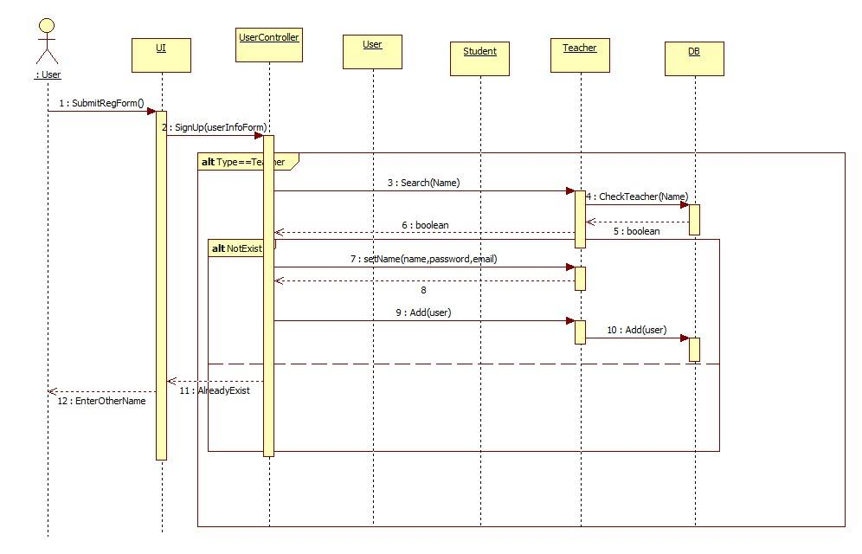

### 

1. **Add Game**

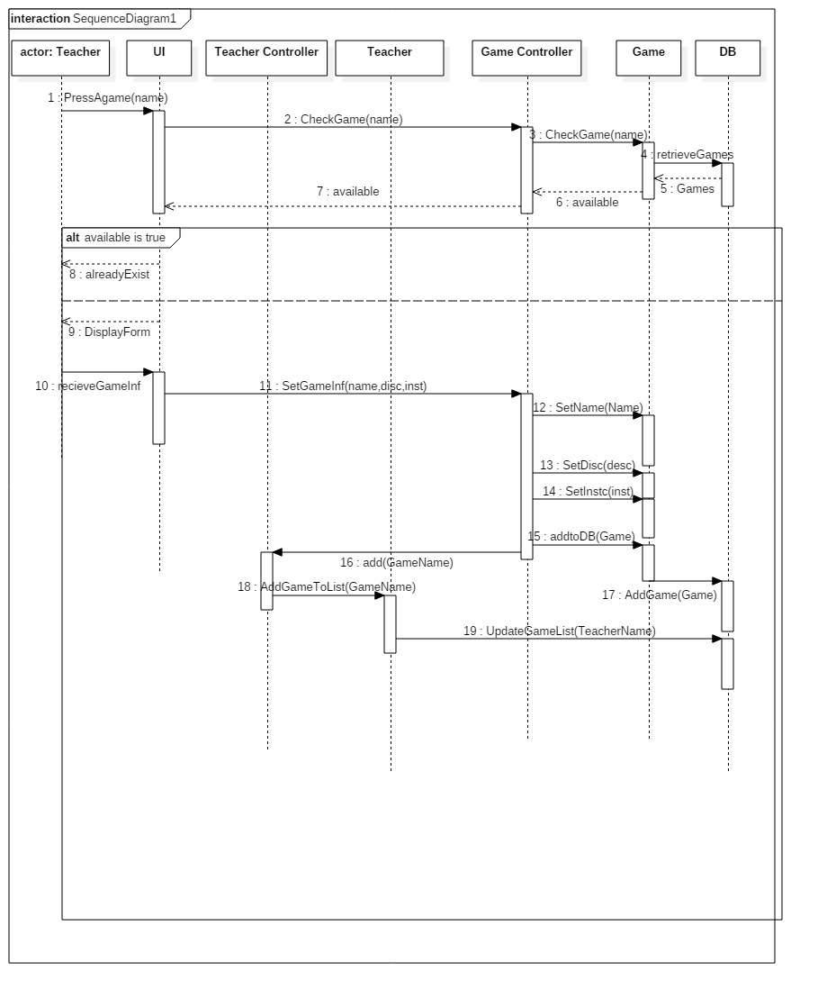

1. **Play Game**

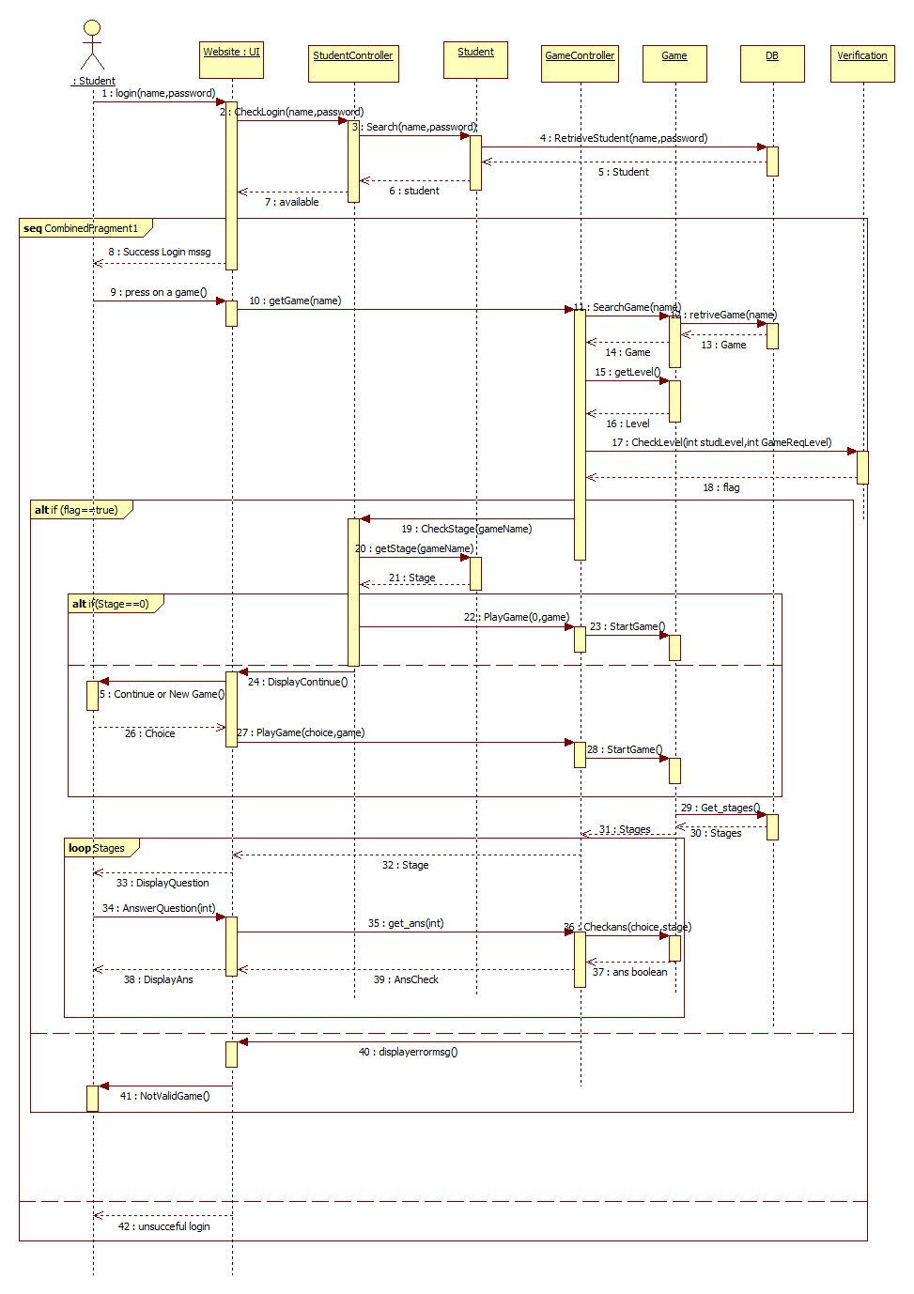

### Class - Sequence Usage Table

| **Class Name** | **Sequence Diagrams** | **Overall used methods** |
| --- | --- | --- |
| UI | 1,2,3 | PressAgame(name),Register(),LogIn(),  DisplayAllGame(),ChooseOrCont() |
| User | 1 | SetName(),SetEmail(),  SetPassword(),SetType(),  getType(), |
| Teacher | 1,2 | AddToGameList(),AddTecacher() |
| Student | 1,3 | SetLevel(),GetLevel(),GetStage(),  AddGameToList(),AddStudent(),SearchStudent(), |
| Game | 2,3 | SearchGame(),StartGame , GetLevel(),SetName(),SetInstruction(),GetInstruction(),SetDiscription(),AddToDB(),SetRiquiredLevel(),GetRiuiredLevel(),CheckGame(), |
| DB | 1,2,3 | RetriveGame(),AddGame,  UpdateGameList(),InsertTeacher(),InsertStudent() |
| User_ Controller | 1 | CreateNewUser(), |
| Teacher_Controller | 1,2 | NewTeacher(), |
| Student _Controller | 1,3 | NewStudent(), |
| Game_ Controller | 2,3 | CheckGame(),SetName() ,SetInstruction(),SetDiscription(),  AddToDB(), |
| Verification | 2 |  |

GITHUB:  
https://github.com/Ziad-Aamer/SW_Project